Abstract—As the global warming and the increase in seawater level threatens more and more people all around the world, we still lack of accurate and actual data about the water quality.
Autonomous underwater measure unit
MULAC Nino, DUMAND Nathan.
We are currently working on the Fishe, a boat with a submarine measure unit. It is based on a hovercraft propulsion system, and the buoyancy of a catamaran. It measures temperature, pH, and turbidity and process it thanks to an Jetson Nano.

Index Terms—Boat robot, Raspberry Pi, Jetson Nano, Temperature, pH

INTRODUCTION
THIS document is a presentation of the project, the Fishe. We decided to create a boat, which will observe the quality of water as it’s a main issue nowadays [1].
A lot a quality monitoring robots already exist, but none of those analyze high ranges of water depth : they are either just floating boats [2] or underwater rovers [3]-[4], good for swimming pools but unable to move in the sea, because of the obstacles in the sea depths.
The main point of work in our project is based on the movement and the buoyancy of the boat but also the sensor that will allow data recovery in deep sea and finally the brain that will analyze and processed it.

SHELL

Watertightness
The first issue faced was the watertightness : We decided as a first approach to make it as two nested shells, this way, even if one broke, the other would still hold, but it was too heavy, so we ha to move to a different approach. Now we are using a shell printed in a 3d printer, with only one wire, spiraling all the way to the top of the shell. We now have a very light shell, almost 50g, so four times lighter than the previous one. But if it collides with a rock, it will break and the water will flow in. So we will fill it with expansive foam, to have a light and full shell.

Drag coefficient
The shell is very important for the movement. If we want to model the movement, we must use the drag force, defined by

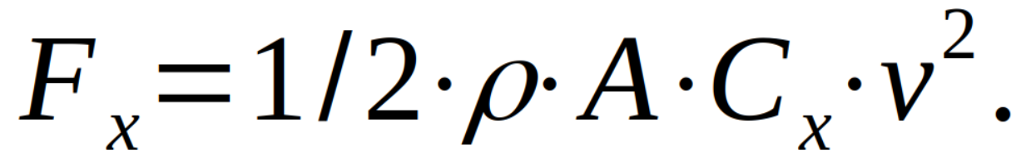 (1)
With ρ the mass density of the water, A the immersed area, C_{x} the drag coefficient, and v the relative speed (1). We chose to use a catamaran shell shape, to lower the area [5]. We could also make a full shell, but it would increase the area at least thrice. It would increase buoyancy a lot though.
We are trying to measure the drag coefficient of our shell with a drag test.
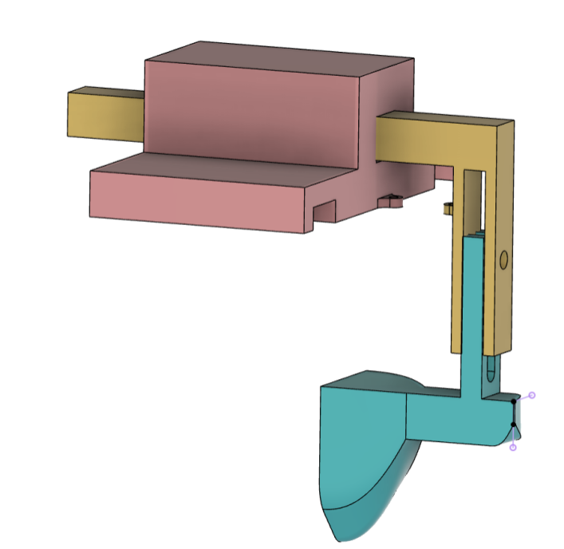Fig. 1. Drag test, yellow part will slide in pink part

A spring between the yellow and the pink part will allow us to measure the drag force depending on the Reynolds Number, allowing us to estimate the drag coefficient. For now, we use 0.3 as it seems a good estimation.

MOVEMENT

Brushless motor
After thinking about how our propulsion will take place, we choose to use a brushless motor, which allow us to maximize the efficacy [6]. To use the motor efficiently, we use a bidirectional ESC [7]. Test show us that it is possible to rotate backwards or forwards. The rotation speed can be chose as desired.
To allow the Fishes to sail, we add a propeller to study more easily the motor.
At the moment we use a power supply because it’s easier to test.

Protection
The motor need protection to resist water splash. We designed a protection to cover the rotor and stator. The center is almost full cover and only let an access to the wire. The back of the motor will be fixed but we must let a space to allow the rotation. The shaft will also be protected by a removable part.
Furthermore, the design enable it to redirect the air flow [8]. That will help us to control the direction. It will also protect the propeller from projectile and water.
There are some reinforcements to strengthen external part. Those reinforcements will also be the support for the rudders, which will be fixed on it.
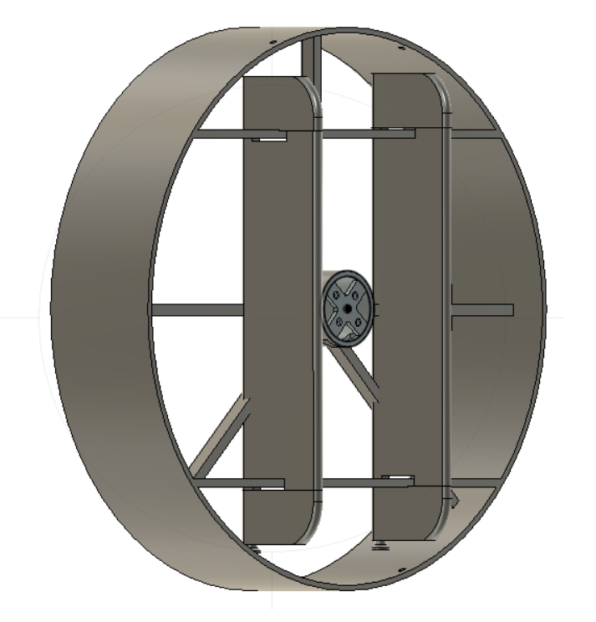
Fig. 2. View of motor cover. The central part protect the brushless motor, external one redirect air flow and protect the propeller. Two rudders are fixed on reinforcement

Direction
Two rudders will assure the directional part of the Fishes.
They are laid around the reinforcement thanks to little clips. In addition, they will be fix together to assure a better reaction and rotation.
They stay thanks to metal rod, which will go through all the three part of the rudder. A servomotor will provide the rotation. Each rudders are linked to the servomotor with an elastic fixed around the pin in the bottom of the piece

Sensors
To monitor water acidity, we use a pH-meter. As we want something precise, we needed to calibrate the sensor [9]. This calibration was something necessary. During the calibration, we found that depending of the analog converter, the correction applicate to have a good result varies. The calibration was for a neuter pH, i.e. 7, and as we move away, we lose accuracy (+/- 0.05 for a Ph at 4).

INFORMATICS
We need two different controllers for the navigation unit and the measure unit. Because of our constraints, we chose to use a Jetson Nano for the navigation unit, and to add it an additional disk of 500Go to have a lot of space, the internal disk isn’t sufficient at all since it is only 16Go, including the OS. A SD card could have been enough, but, with a whole disk, we can use it as storage, not only for data, but also for software. The problem of the Jetson Nano is that its PWM isn’t configured for use, we need to edit the Nano’s properties.
For the measure unit, we chose first to use a Raspberry Pi 0 W to use its wireless features, but it doesn’t have any analog input, so we switched to a Raspberry Pi Pico W.
For the measure unit, we chose first to use a Raspberry Pi 0 W to use its wireless features, but it doesn’t have any analog input, so we switched to a Raspberry Pi Pico W.
To ensure the safe transfer of data between the two modules of the fishe, we decided to use a web server, built in python with Django. Its advantages are the ease of use: a simple POST request can send all the data of a measure. Then all the data is stored on a database on the hard drive.
The Jetson Nano will create a Wi-Fi hotspot, and the Raspberry Pi Pico will connect to it when it gets back up. This way, even if they are not connected to the internet, they can exchange simple requests like the ones containing the measures.

CONCLUSION
In conclusion, for the movement after studying different type of motor (motor DC, servo motor or even stepper motor) we picked the brushless motor, which is easy to control.
We will soon have a more precise drag coefficient, but we can estimate it around 0.3 for now. The shell’s water tightness was a problem too, because flexible seals aren’t tight enough.
We had some problems with the informatics part, especially on the Jetson Nano being badly configured, but we managed to overcome them. We made a compromise because we can’t use too much sensor. We reduced our choice to the temperature, pH-meter and turbidity ones. Those different sensors we choose allow the Fishe to see water quality at different coordinate and remember it thanks to the Jetson Nano to understand where the sea is pollute or at which point we can see different water type (river, sea …).

REFERENCES
- https://en.wikipedia.org/wiki/Intergovernmental_Panel_on_Climate_Change
- https://ieeexplore.ieee.org/abstract/document/6960116
- https://www.sciencedirect.com/science/article/pii/S0141933198000830
- https://iopscience.iop.org/article/10.1088/1757-899X/1033/1/012013/pdf
- https://en.wikipedia.org/wiki/Drag_coefficient
- https://arduino.blaisepascal.fr/controler-un-moteur-brushless/
- https://forum.arduino.cc/t/how-to-reverse-motor-direction-with-esc-with-reverse-function/668118/4
- https://www.sciencedirect.com/science/article/pii/S0141933198000830
- https://how2electronics.com/ph-meter-using-ph-sensor-arduino-oled/
- https://github.com/Ekter/fishe

Nino MULAC was born at 2nd december 2002. He graduated in 2020. He made an internship in the LNEC(Laboratory of Experimental and Clinical Neurosciences). After two years of PeiP, he is now in third year in Robotics and Autonomous systems.

Nathan DUMAND was born in St-Jean-de-Braye in France in 2002. He graduated a Bachelor’s degree with the specialty of engineering sciences in 2020 and he study for an engineering degree in robotics, autonomous system at Polytech Nice-Sophia localized in Biot in France

 

